Weather Agent Lab: Identity Flow Reference
Okta for AI Agents (ID-JAG), agentgateway, Claude on Amazon Bedrock
Living document. Author: Michael Steinberg. Last updated: September 29, 2026.

1. Purpose and scope
This document is the reference for the weather agent lab: an AI agent that answers weather questions using Claude on Amazon Bedrock, calling an MCP tool server through agentgateway, with every step governed by Okta for AI Agents (O4AA). It records what talks to what, what is sent on each hop, and what each receiver verifies before trusting anything.
It will be extended as the lab progresses: agent app implementation, gateway authentication, scope-based tool authorization, and the move to Amazon Bedrock AgentCore Runtime.

1.1 Current lab state
Component | Status | Notes
weather_server.py (MCP server) | Running | systemd service on EC2, bound to 127.0.0.1:8000; tools get_current_weather and reset_cache (stub)
agentgateway | Running | systemd service on EC2, listener on port 3000; CEL rule currently allows only get_current_weather; no authentication yet
agent-remote.py | Working | Local agent: Bedrock Converse loop plus MCP client through the gateway (SSH tunnel)
Okta custom AS weather-mcp-as | Configured | Audience api://weather-mcp; scopes weather:read, weather:admin; access policy with JWT Bearer rule
O4AA agent weather-agent | Configured | Client ID wlp1484ahtldhvoMS1d8; private key JWT (kid ab08352b91f74b809962cc33947d736b); linked OIDC app; user assigned
Resource connection | Active | weather-agent to weather-mcp-as (audience api://weather-mcp), Only allow weather:read
Flask agent app | In progress | Stages 1 to 3 (sign-in and both exchanges) verified 2026-09-29; stage 4 (Bedrock and MCP loop) after gateway authentication
Gateway authentication | Not started | mcpAuthentication against weather-mcp-as; scope-based CEL rules

2. Architecture
The agent app is the hub: every connection except the browser's sign-in redirect starts there.
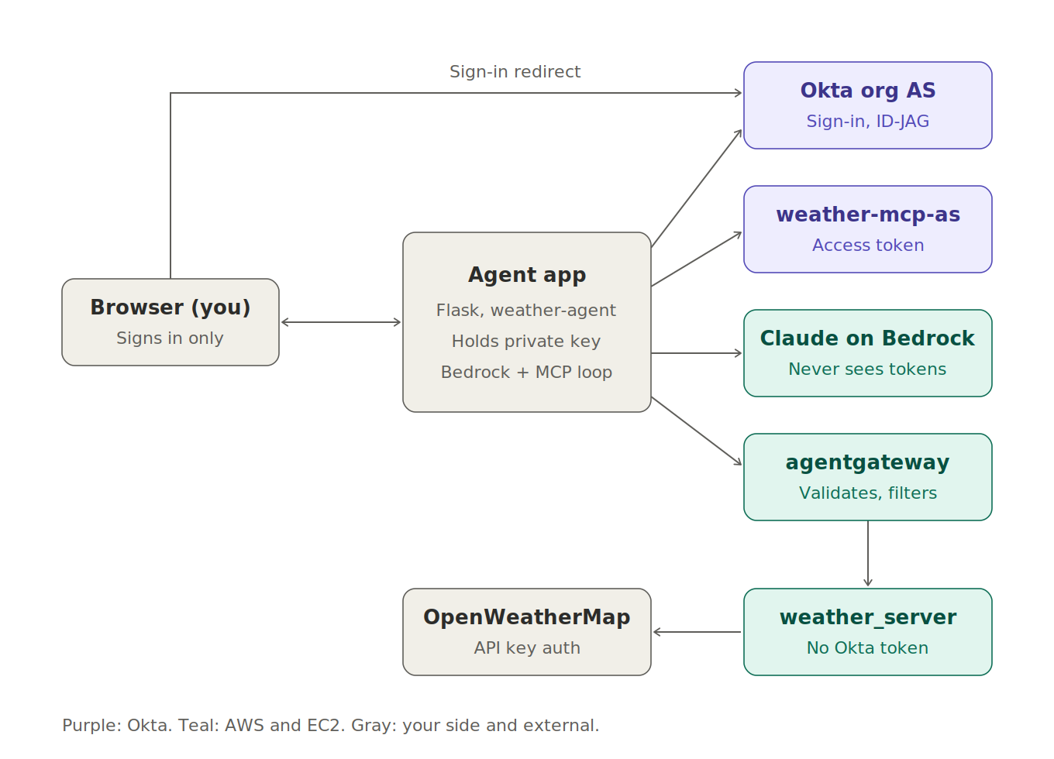
Figure 1. Participants and connections

3. Participants and identifiers
Party | Identifier | Credential it holds
You | Your Okta user | Password and a second factor
Agent app (weather-agent) | Client ID wlp1484ahtldhvoMS1d8 | Private key, kid ab08352b91f74b809962cc33947d736b
Okta org AS | Issuer https://demo-citizensbank-o4aa.oktapreview.com | Its own signing keys, published at /oauth2/v1/keys
weather-mcp-as | Issuer https://demo-citizensbank-o4aa.oktapreview.com/oauth2/aus14831p0s2MFyjM1d8 | Its own signing keys, published at .../v1/keys
agentgateway | Expects audience api://weather-mcp | None; it only verifies
Amazon Bedrock | Your AWS account | AWS SSO credentials, held by the agent app
OpenWeatherMap | n/a | weather_server's API key

3.1 Key Okta design facts
- In O4AA, the AI agent and its linked OIDC app are one OAuth client: the app shows the same wlp... client ID and the same public key as the agent.
- The binding between agent and linked app is permanent. Changing it requires deleting the agent.
- The linked app's grants are Authorization Code and Token Exchange, managed by O4AA. The JWT Bearer grant is enabled in the access policy rule on weather-mcp-as, not on the app.
- Resource connections define what the agent can reach. Machine access defines who can call the agent; it is intentionally left empty in this lab.

3.2 Okta build order used
# | Step | Why it is in this position
1 | Custom authorization server weather-mcp-as with audience and scopes | No dependencies; Okta lists it as a prerequisite
2 | Register AI agent with "Create a new OIDC app linked to this AI agent" | Creates and permanently binds the linked app
3 | Client registration: public/private key, activated | Required before the agent can authenticate
4 | Activate the agent | The linked app is inactive until then, which blocks user assignment
5 | Assign users; set redirect URIs on the linked app | Requires an active app
6 | Access policy and JWT Bearer rule on weather-mcp-as | Requires the agent to exist as a client
7 | Resource connection to weather-mcp-as, Only allow weather:read | Requires the access policy to exist

4. The client assertion (private_key_jwt)
Every time the agent app calls an Okta token endpoint, it proves it is weather-agent with a short JWT signed by its private key. This building block is used three times in the flow.
Part | Contents
Header | alg: RS256, kid: ab08352b91f74b809962cc33947d736b
Claims | iss and sub = wlp1484ahtldhvoMS1d8; aud = the exact token endpoint being called; jti = unique ID; exp = a few minutes from now
Sent as | client_assertion_type=urn:ietf:params:oauth:client-assertion-type:jwt-bearer and client_assertion=<JWT>

Okta verifies: the signature against the registered public key with that kid; that aud is its own endpoint; that the assertion has not expired; and that the jti has not been used before (replay protection). The private key never leaves the agent app.

5. End-to-end flow
The flow has four phases. Phases 1 to 3 run once per sign-in (or when the access token expires); phase 4 repeats for every question.

Phase 1: Sign-in (authorization code with PKCE)

Step 1. Browser to agent app: GET /login
The app generates a random state (CSRF protection), a nonce (ID token replay protection), and a PKCE code_verifier, and stores all three in the server-side session.

Step 2. Agent app to browser: redirect to the org AS
A 302 redirect to https://demo-citizensbank-o4aa.oktapreview.com/oauth2/v1/authorize with client_id=wlp1484ahtldhvoMS1d8, response_type=code, scope=openid profile email, redirect_uri=http://localhost:5000/callback, state, nonce, code_challenge (SHA-256 of the verifier), and code_challenge_method=S256.

Step 3. Browser to org AS: you authenticate
Okta verifies: the client_id exists and the redirect_uri exactly matches a registered URI; your password and a second factor ("Any two factors"); and that you are assigned to the app.

Step 4. Org AS to browser to agent app: /callback?code=...&state=...
Agent app verifies: state matches the session. A mismatch means a forged callback, so the app stops.

Step 5. Agent app to org AS: POST /oauth2/v1/token
Sends grant_type=authorization_code, code, redirect_uri, code_verifier, and a client assertion.
Okta verifies: the client assertion; that the code is valid, unused, and was issued to this client for this redirect URI; and that the SHA-256 of code_verifier matches the earlier code_challenge, proving the requester is the one who started the sign-in.

Step 6. Org AS to agent app: ID token (plus an Okta access token, ignored)
Agent app verifies the ID token: signature against the org AS keys; iss = the org issuer; aud = wlp1484ahtldhvoMS1d8; exp; and nonce = the session nonce.
The ID token stays on the server, in the session. The browser only holds a session cookie. The Okta access token returned at sign-in has Okta itself as its audience and is not used; it would be rejected by the gateway.

Phase 2: Exchange 1, ID token to ID-JAG (org AS)
Question answered: who is this, and did they delegate to this agent? The org AS acts as the identity provider; it vouches for identity and delegation but makes no permission decision.

Step 7. Agent app to org AS: POST /oauth2/v1/token
Parameter | Value
grant_type | urn:ietf:params:oauth:grant-type:token-exchange
requested_token_type | urn:ietf:params:oauth:token-type:id-jag
subject_token | Your ID token
subject_token_type | urn:ietf:params:oauth:token-type:id_token
audience | weather-mcp-as issuer URL (not its token endpoint)
scope | weather:read
Client authentication | Client assertion

Okta verifies: the client assertion (this is weather-agent); that the subject token is a valid ID token Okta issued to this same client; that the agent is active; that the agent has a resource connection to the audience authorization server; and that the requested scope is within the connection's cap.

Step 8. Org AS to agent app: ID-JAG
A short-lived JWT (five minutes, typ: oauth-id-jag+jwt) stating that this user has delegated to this client, for this authorization server. Observed claims are recorded in section 8, stage 2.

Phase 3: Exchange 2, ID-JAG to access token (weather-mcp-as)
Question answered: what may this agent do, for this user, at this resource? The resource's authorization server trusts the identity assertion but applies its own policy.

Step 9. Agent app to weather-mcp-as: POST .../oauth2/aus14831p0s2MFyjM1d8/v1/token
Sends grant_type=urn:ietf:params:oauth:grant-type:jwt-bearer, assertion=<ID-JAG>, scope=weather:read, and a client assertion whose aud is now this token endpoint.
weather-mcp-as verifies:
- The client assertion.
- The ID-JAG: signature against the org AS keys, its issuer, that its audience is this server, that it has not expired, and that the client it names is the one authenticating now.
- The access policy rule: client is weather-agent, grant is JWT Bearer, user is assigned, scope is allowed.

Step 10. weather-mcp-as to agent app: access token
Claim | Expected value
iss | https://demo-citizensbank-o4aa.oktapreview.com/oauth2/aus14831p0s2MFyjM1d8
aud | api://weather-mcp
sub | Your Okta username (email), e.g. Michael.Steinberg@citizensbank.com
uid | Your Okta user ID, 00u130qrbmt0RIMTv1d8
cid | wlp1484ahtldhvoMS1d8
scp | ["weather:read"] (array)
act | {sub: wlp1484ahtldhvoMS1d8, sub_profile: "ai_agent web_app"}
exp | One hour after issue

This token carries both identities: a specific user (sub, uid), acting through a specific agent (cid, act), with specific permissions (scp), for a specific resource (aud). Confirmed against a real token in section 8, stage 3.

Phase 4: Answering a question

Step 11. Browser to agent app: POST /ask
Agent app verifies: the session is valid, plus a CSRF token for form posts.

Step 12. Agent app to agentgateway: MCP initialize with Authorization: Bearer <access token>
Gateway verifies, on this and every later request: signature against weather-mcp-as's JWKS (fetched and cached); iss; aud = api://weather-mcp; and exp. Any failure returns 401, and nothing reaches the backend.

Step 13. Gateway to weather_server: separate MCP session
The gateway maintains its own MCP session with the backend. To be verified: that the gateway does not pass the user's Authorization header through to the backend (no token passthrough).

Step 14. Agent app to gateway: tools/list
Gateway evaluates: the CEL rules for each tool using jwt.scp, and returns only the allowed tools.

Step 15. Agent app to Bedrock: Converse
Sends the question and the filtered tool list, signed with AWS SigV4 from the AWS session.
Bedrock verifies: IAM permissions for the model. No Okta token is involved.

Step 16. Bedrock to agent app: toolUse
For example get_current_weather({"city": "Denver,US"}).

Step 17. Agent app to gateway: tools/call with the bearer token
Gateway: re-verifies the token, evaluates the CEL rules for this specific tool, and logs the call (method, tool, target, and caller identity).

Step 18. Gateway to weather_server to OpenWeatherMap
The server calls OpenWeatherMap with its own API key. The result flows back through the gateway to the agent app.

Step 19. Agent app to Bedrock: toolResult; Bedrock returns the final text

Step 20. Agent app to browser: the answer page

6. Token summary
Token | Issued by | Audience | Used for
ID token | Org AS | wlp1484ahtldhvoMS1d8 | Input to exchange 1 (proof of sign-in)
Sign-in access token | Org AS | Okta | Not used
ID-JAG | Org AS | weather-mcp-as | Input to exchange 2
Weather access token | weather-mcp-as | api://weather-mcp | Bearer token on every MCP request
Client assertion | Agent app (self-signed) | The token endpoint called | Client authentication on every Okta call

7. Security invariants
The implementation must hold to these:
- The private key never leaves the agent app. Every Okta call uses a fresh, single-use client assertion instead.
- The browser never sees a token. It holds only a session cookie.
- Each token is accepted only by its intended audience: the ID token by the org AS (exchange 1), the ID-JAG by weather-mcp-as, and the access token by the gateway.
- Every token is signature-checked against its issuer's published keys before its claims are trusted.
- The model is outside the identity chain. It never holds a credential, so it cannot leak or misuse one.
- The MCP server authenticates to its upstream API with its own credential, never a user's token (no token passthrough, per the MCP authorization spec).
- New tools are denied by default: a tool is invisible until a gateway CEL rule maps it to a scope.

8. Agent app build log
The agent app is built in four stages, each verified before the next: (1) sign-in, (2) exchange 1, (3) exchange 2, (4) the Bedrock and MCP loop. Code lives in ~/python-projects/weather-api: okta.py (client assertion, PKCE, token requests, JWT checks) and web.py (Flask routes, server-side session store).

Stage 1: Sign-in (verified 2026-09-29)
Authorization code flow with PKCE against the org AS, client authentication by private_key_jwt. The ID token is verified (signature, iss, aud, exp, nonce) and stored server-side; the browser holds only a random session ID.
Claim | Observed | Significance
iss | https://demo-citizensbank-o4aa.oktapreview.com | Org AS, where exchange 1 is sent
aud | wlp1484ahtldhvoMS1d8 | Issued to the agent; the check that failed in the September 21 build
sub | 00u130qrbmt0RIMTv1d8 | Okta user ID; expected to carry through to the final access token
amr | swk, okta_verify | Two factors, satisfying the app's "Any two factors" policy
exp minus iat | 3600 seconds | Exchange 1 must occur within one hour of sign-in
nonce | Matches session | Replay protection, checked by the app
at_hash | Present | Binds the ID token to the (discarded) sign-in access token

The token endpoint also returned Okta's own access token (audience: Okta). The app discards it; it is not used anywhere in the flow.

Stage 2: Exchange 1, ID token to ID-JAG (verified 2026-09-29)
Token exchange at the org AS with requested_token_type of ID-JAG and audience set to the weather-mcp-as issuer. Succeeded on the first attempt.

Response metadata
Field | Observed
issued_token_type | urn:ietf:params:oauth:token-type:id-jag
token_type | N_A (not a bearer token for any API)
expires_in | 300 seconds: exchange 2 must follow within five minutes

ID-JAG header and claims
Field | Observed | Significance
typ (header) | oauth-id-jag+jwt | Explicit token type, so it cannot be confused with an ID or access token
kid (header) | Same key as the ID token | Signed by the org AS
iss | https://demo-citizensbank-o4aa.oktapreview.com | Org AS
aud | .../oauth2/aus14831p0s2MFyjM1d8 | Addressed to weather-mcp-as only
sub | 00u130qrbmt0RIMTv1d8 | The user, carried from the ID token
sub_profile | user | The subject is a human
client_id | wlp1484ahtldhvoMS1d8 | The client allowed to redeem it
scope | weather:read | Requested scope, within the resource connection cap
act.sub | wlp1484ahtldhvoMS1d8 | RFC 8693 actor claim: the agent acting for the user
act.sub_profile | ai_agent web_app | The actor is an AI agent with a linked web app
exp minus iat | 300 seconds | Short-lived by design

The act claim records the delegation chain explicitly: the subject is the user, and the actor is the agent. In multi-hop scenarios, act claims nest to record each hop.

Stage 3: Exchange 2, ID-JAG to access token (verified 2026-09-29)
JWT bearer grant at weather-mcp-as with the ID-JAG as the assertion. The app verified the result with the same checks agentgateway will apply: signature against weather-mcp-as JWKS, iss, aud = api://weather-mcp, and exp. All passed. The ID-JAG is removed from the session after use (single use).

Response metadata
Field | Observed
token_type | Bearer
expires_in | 3600 seconds
scope | weather:read

Access token header and claims
Field | Observed | Significance
kid (header) | FVBB0OVZ... (differs from org AS key) | Signed by weather-mcp-as with its own key
iss | .../oauth2/aus14831p0s2MFyjM1d8 | Gateway must require this issuer
aud | api://weather-mcp | Gateway must require this audience
sub | Michael.Steinberg@citizensbank.com | Username, not the 00u ID used in the ID token and ID-JAG
uid | 00u130qrbmt0RIMTv1d8 | Stable user ID; preferred for rules and audit
sub_profile | user | Subject is a human
cid | wlp1484ahtldhvoMS1d8 | The agent that obtained the token
act.sub | wlp1484ahtldhvoMS1d8 | Actor claim carried through from the ID-JAG
act.sub_profile | ai_agent web_app | Actor is an AI agent
scp | ["weather:read"] | JSON array, so CEL "weather:read" in jwt.scp works directly
exp minus iat | 3600 seconds | Matches the access policy rule's one-hour lifetime

Findings that affect gateway rules
- The sub claim changes form. It is the user ID in the ID token and ID-JAG but the username (email) in the access token. Rules and audit logs should key on jwt.uid for a stable identifier, not jwt.sub.
- The act claim survives both exchanges. The gateway can distinguish agent traffic from direct user traffic, for example by requiring has(jwt.act) or checking jwt.act.sub_profile.
- The scp claim is an array, as expected for Okta, so scope checks need no string splitting.

9. Open items
- Agent app stage 4: the Bedrock and MCP loop, sending the access token to the gateway.
- Add mcpAuthentication to agentgateway (issuer and JWKS of weather-mcp-as, audience api://weather-mcp) and move CEL rules to scope checks; test with curl before stage 4.
- Confirm no token passthrough from gateway to weather_server.
- Decide access token caching and refresh behavior.
- TLS on the gateway, open port 3000, then move the agent to AgentCore Runtime and hand token acquisition to AgentCore Identity.

Change log
Date | Change
2026-09-28 | Initial version: architecture, participants, Okta build order, full 20-step flow, token summary, invariants
2026-09-28 | Resource connection confirmed Active; Okta configuration complete
2026-09-29 | Added agent app build log; stage 1 (sign-in) verified with observed ID token claims
2026-09-29 | Stage 2 (exchange 1) verified; ID-JAG format and act claim recorded
2026-09-29 | Stage 3 (exchange 2) verified; access token claims recorded; step 10 corrected (sub is username, uid added, act present)

